How to Activate your Cengage Unlimited Subscription

- Click on the following link: Activate your Cengage Unlimited Subscription Here or copy and paste this link into your web address bar https://www.cengage.com/dashboard/#/course-confirmation/MTPPKVSQ5PRT/initial-course-confirmation.
- You will then be asked to sign into your Cengage account. Sign in using the Cengage account that you created. *If you have not yet created your Cengage account, click on Create Student Account option on the sign in screen.
- Once you have signed in you will see the screen below. Click on the Continue button at the bottom of the page.
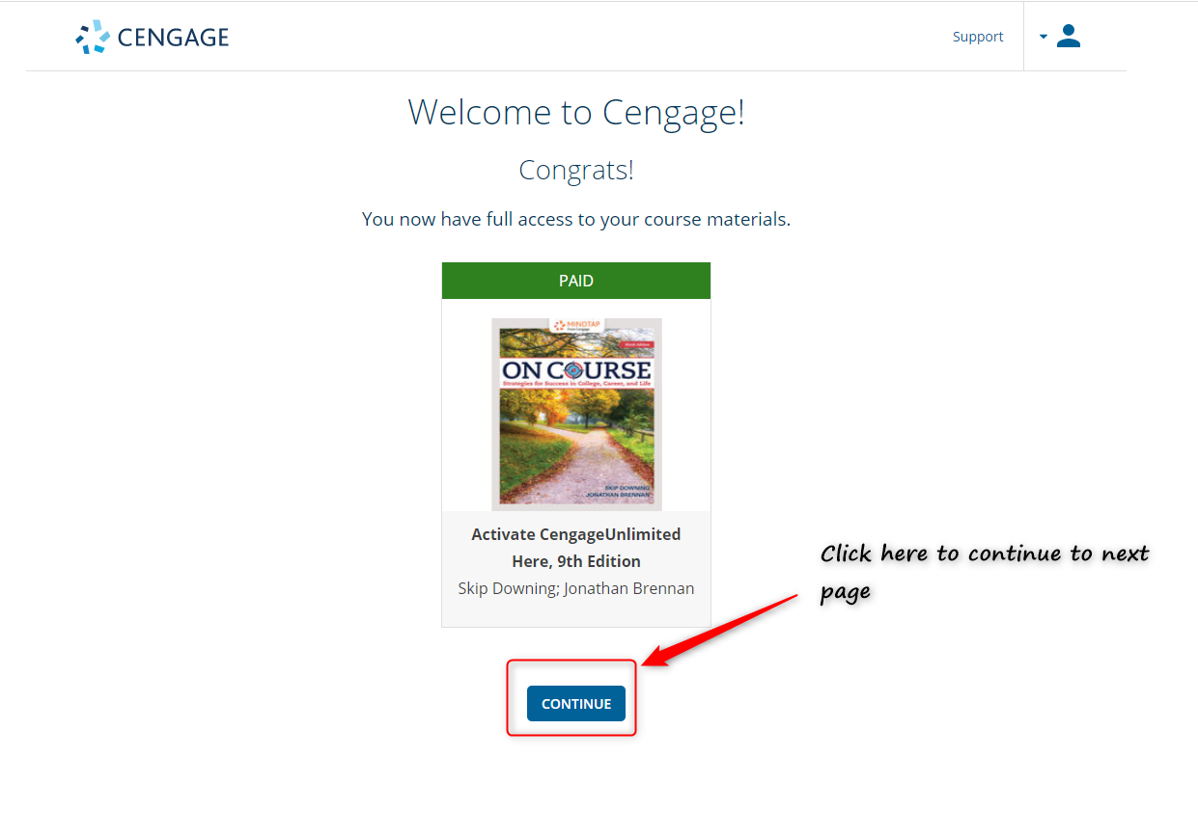
- After clicking on the Continue button, you will be directed to the screen shown below. You will want to click on the Continue button once again at the bottom of the far-right column. This will activate your Cengage Unlimited subscription.
