How to add an eBook to your Cengage Account

- After you have created your account and activated your Cengage Unlimited subscription, you will want to click on the magnifying glass in the top right-hand corner of your home page.
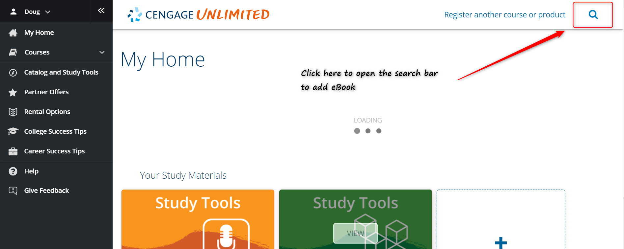

- Once you have clicked on the magnifying glass as search box will appear. You can search by the ISBN (provided by instructor), Author or Title of the text that you are wanting to add. Then hit Enter or click on the magnifying glass to the right of the search box.
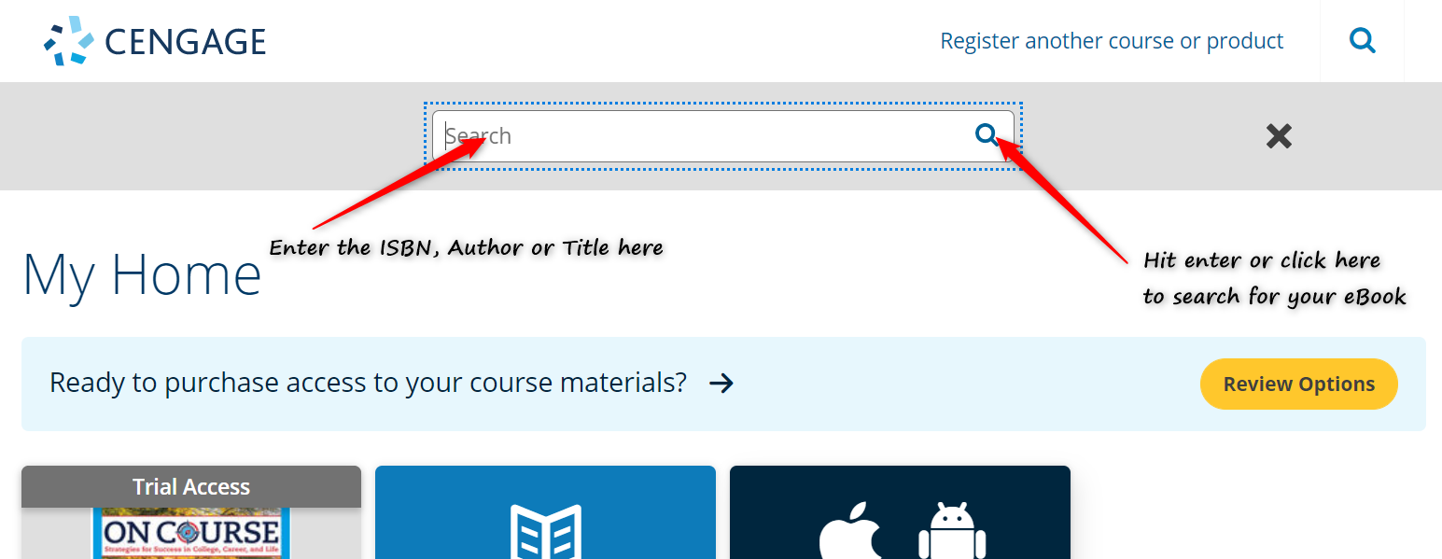

- After you hit enter or click on the magnifying glass to search for your eBook, you will see options populate below the search bar. You want to find the text that you are looking for (make sure that it has eBook listed in the title) and then click on the Add to My Home option.
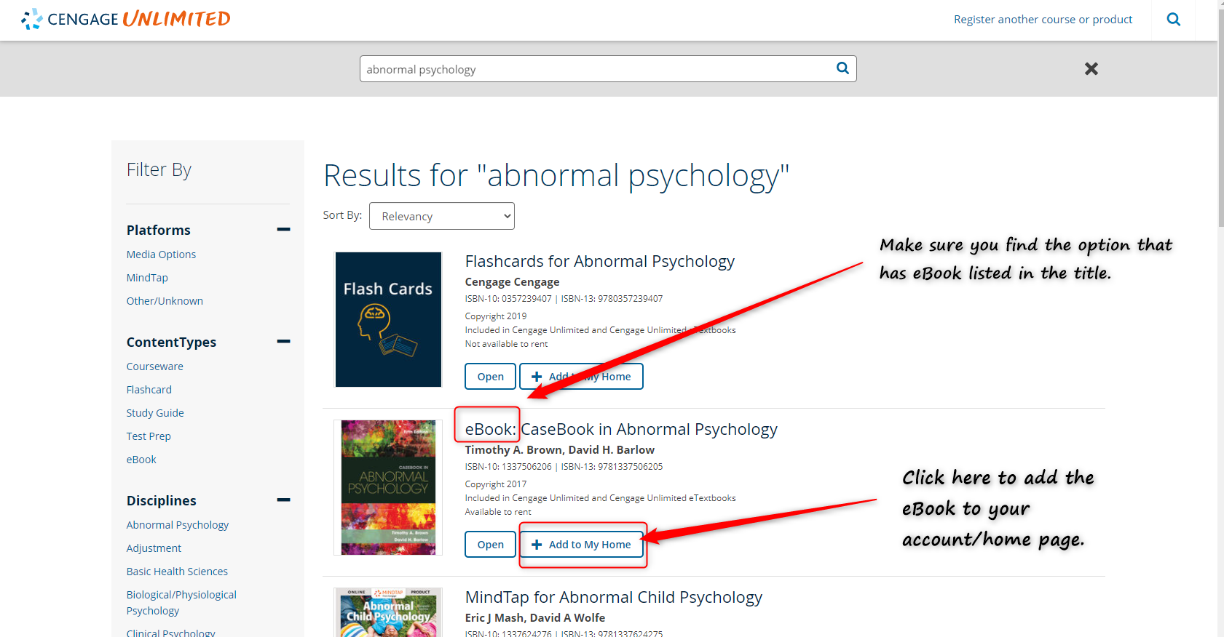

- Once you have click on the Add to My Home, your eBook will be added to your account/home page. You can click on the My Home option on the top left-hand corner of the page in the black menu bar to access the eBook.
