How to Access Your Digital Platform (MindTap, WebAssign, OWL, CNOWv2, SAM)

- Log into your Cengage account at http://login.cengage.com.
- After you have logged in, click on the link on the top right-hand side of the page titled Register another course or product.
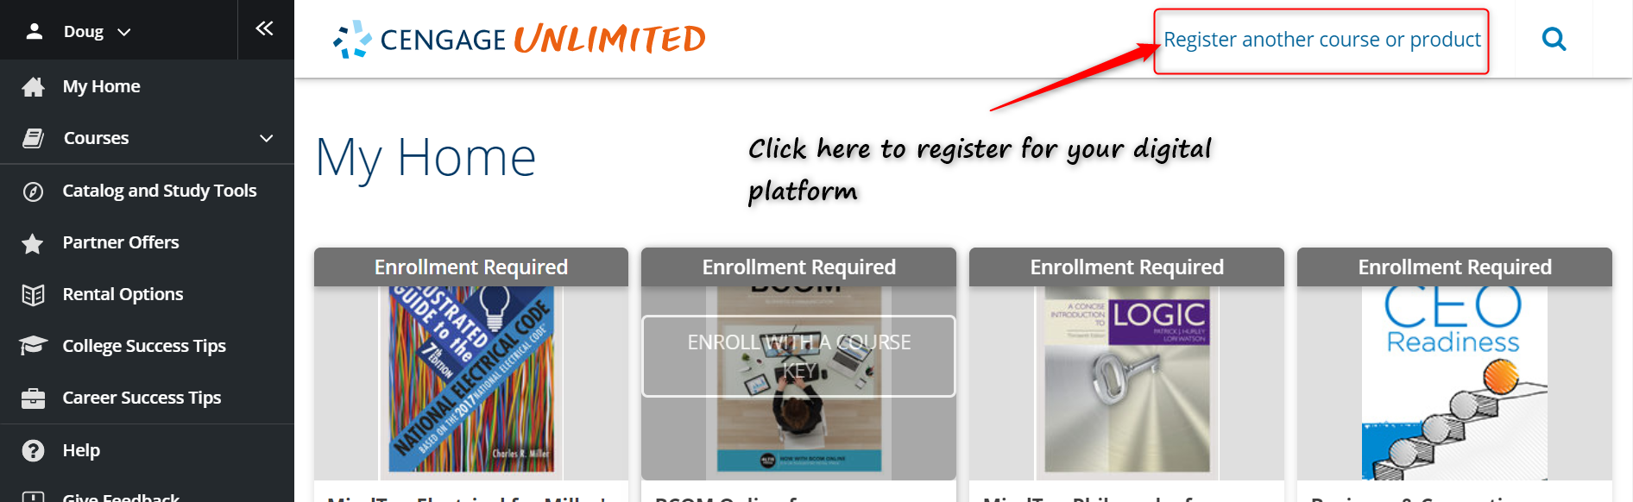

- After you have clicked on the Register another course or product link, a box will appear with a text box. In the text box you will want to enter the course key for your course. The course key will be provided by your instructor. Once you enter in the course key, click on the Register button.
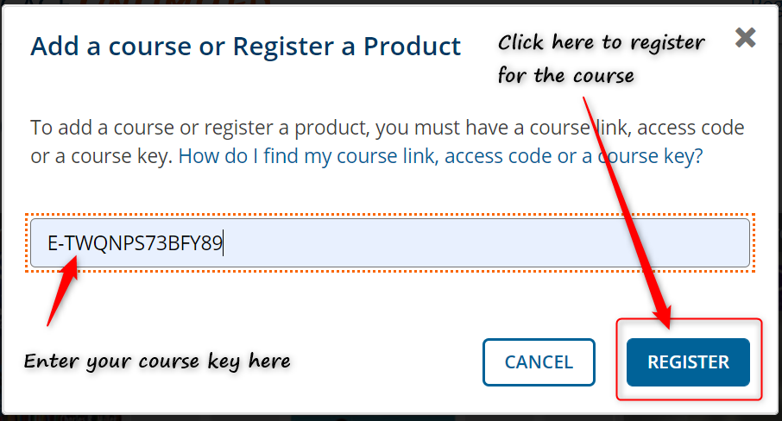
- Once you click on the Register button, you will be registered for the course. You will be redirected to your Cengage home page and you will see that your course has been added. To access the course, click on the title that shows the course that you added.
